ORGANIZATION OF CONCEPTS

# OVERVIEW

After completing the initial brainstorming, 4 concept archetypes have been identified that capture that majority of the ideas we’ve come up with:

* Gantry
* Cable-bot
* Open linkage robot arm
* Closed linkage robot arm

From here, each archetype can be broken down into 2 subcategories, parallel and serial. In the parallel case, the two magnets move completely independently from one another, often on different Z-planes, or different distances from the tablet screen. The parallel configurations can be thought of as two separate 2-DOF robots (that control each magnet’s *x* and *y* position) with some clever geometry at the end of each one to bring the magnets as close together in z-height as possible to minimize differences in magnetic fields created by each magnet.

In the serial configuration, all 4 degrees of freedom on each robot are linked together. This most often takes the form of a 2-DOF mechanism that controls the *x* and *y* position of an end effector which then controls the final 2-DOF–rotation and distance between the points.

With the parallel configuration, it makes sense to have two similar 2-DOF robots, as they must actuate the same degrees of freedom and meet the same requirements. On the other hand, the serial concepts have an end effector that captures different degrees of freedom (distance and angle of the magnets vs. the *x* and *y* position of the end effector itself). Therefore, we also have several different concepts for the end effector that may need prototyping and testing as well.

## 

# 1. GANTRY

## Parallel

**Description**

This system utilizes two gantry systems in different z-planes that can crossover each other. This enables us to achieve any XY position, the rotational degree of freedom, and the pinch degree of freedom by manipulating where the gantries are relative to each other. This would not require the use of an end effector because all degrees of freedom are already achieved.

**Drawings:**

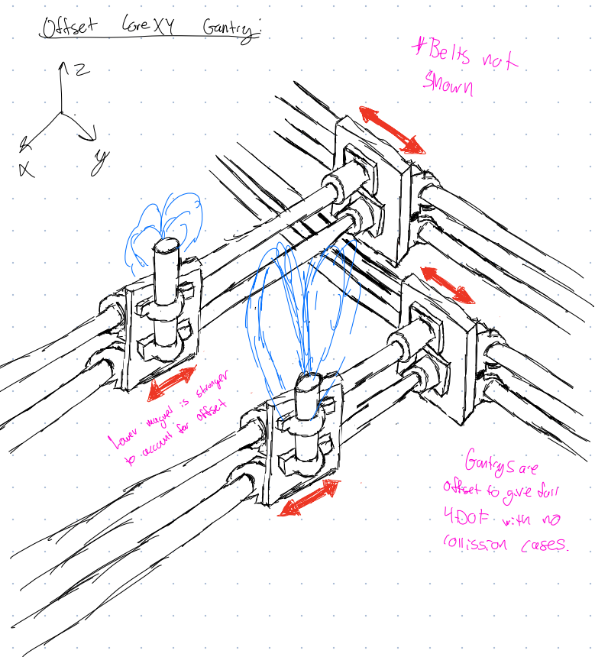

*Here, two separate gantries actuate two electromagnets in both the X and Y directions. They are offset entirely in Z, so there is no way for them to collide at all.*



**Needed tests:**

1. Will there be too much friction in the joints?
2. How much inertia is felt through the end effector?

## Serial

**Description**

This system would utilize a single gantry system that can achieve any XY position and an end effector to achieve the rotational and pinch degree of freedom

**Drawings:**



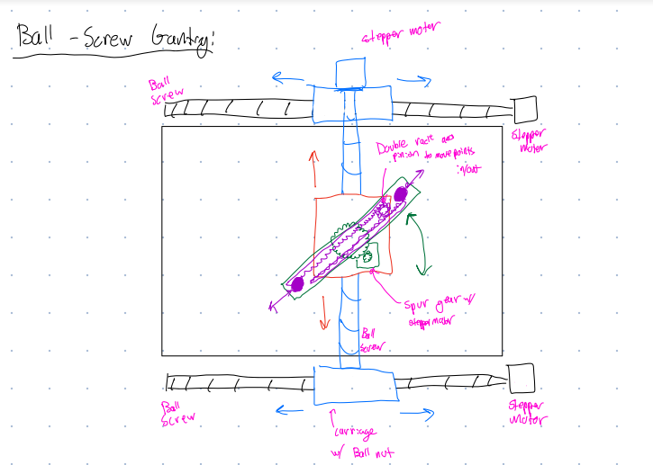

*One concept of the serial gantry involved using ball screws to actuate the gantry. Since ball screws are not backdrivable at all, this design lends itself much more to admittance control.*

**Needed tests:**

1. Will there be too much friction in the joints?
2. How much inertia is felt through the end effector?

# 

# 2. CABLE

## Parallel

**Description:**

Two end effectors at different levels and with magnets of different intensities. Each end effector position is dictated by 3 cables, each with its own motor.

**Block Diagram + Drawings:**



**Needed tests:**

1. How do we deal with the excessive crossover between cables?

## Serial

**Description:**

Only one end effector connected to 4 cables, each with their own motor

**Drawings:**



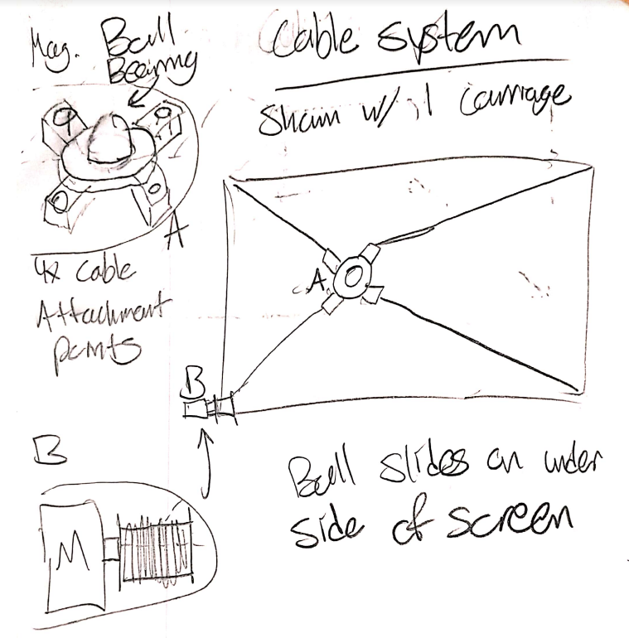

**Needed tests:**

1. Will the carriage’s mass affect positional accuracy?
2. Can we overcome the challenges with keeping constant tension in all of the cables?

# 

# 3. OPEN LINKAGE

## Parallel

**Description:**

This mechanism would utilize two 2DOF open chain linkages, each holding a magnet.

**Drawings:**



**Needed tests:**

1. How can we deal with crossover?
2. How can we deal with/avoid singularities?

## Serial

**Description:**

This mechanism would utilize one 2DOF open chain linkage, containing an end effector to achieve the rotational and pinch degree of freedom

**Drawings:**

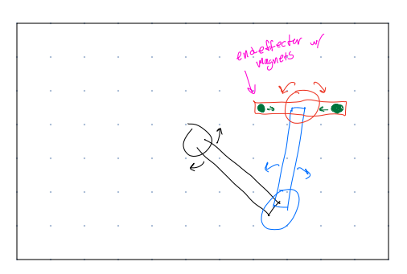

*This is an early ideation for a serial open linkage, and it has one fatal flaw. There is a singularity when the arms fold in on themselves and the end effector is at the home position, meaning it severely limits motion in one direction.*



**Needed tests:**

1. Can we reach all points of our working envelope, and avoid singularity?

# 4. CLOSED LINKAGE

## Parallel

**Description:**

This mechanism would utilize two 2DOF closed chain linkages, each holding a magnet. The relative position of the magnets can be changed independently, achieving our rotation and pinch degree of freedom

**Drawings:**



**Needed tests:**

1. Can we reach all points of our working envelope, and avoid singularities?

## Serial

**Description:**

This mechanism would utilize one 2DOF closed chain linkage, holding two magnets on an end effector.

**Drawings:**



**Needed tests:**

1. How can we deal with/avoid singularities?

# 

# 5. END EFFECTOR

## Disks

**Description:**

To produce the rotation, as well as the pinching motion, two disks would be placed on top of each other, one with a slot and the other with two spirals, like shown below. This is very similar to how a 3 jaw chuck on a lathe functions

**Drawings:**

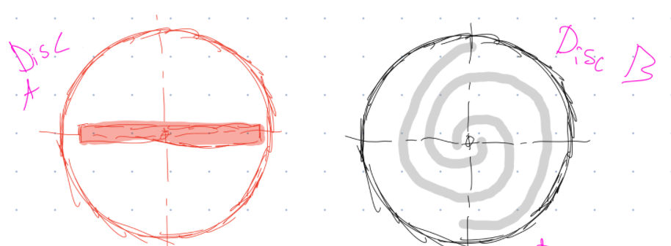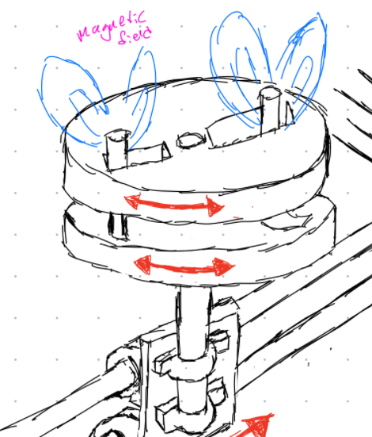

**Needed tests:**

1. How much friction is present with a mechanism like this?
2. Are there issues with backlash?
3. How backdrivable is the system?

## Motor

**Description:**

Placing a servo motor on the carriage - most likely with a gear box

**Drawings:**



**Needed tests:**

* Can we find a light enough motor to still maintain our inertia requirement?

## Motor + Cable

**Description:**

Grounding a servo motor with a tensioned cable belt on the frame, to avoid adding additional mass to the carriage.

**Drawings:**



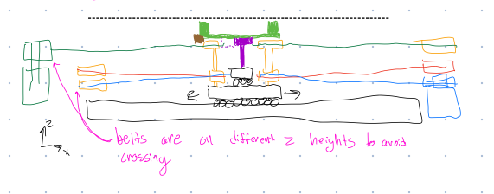

*Here, the green belt actuates the rotation of the two magnets, which are shown in green. This allows for remote actuation of the rotation DOF of the end-effector.*

**Needed tests:**

1. Can we route the cable in such a way to ground the motor?

**SUMMARY OF CONCEPTS**

GREEN: Still a possibility

RED: Idea was excluded

| **Concept** | **Gantry** | **Cable** | **Open Linkage** | **Closed Linkage** |
| --- | --- | --- | --- | --- |
| **Parallel** | Concerns with the amount of friction in the gantry system, especially with binding; could work well if singularities pose too much of an issue for the linkage solutions | Requires 6+ motors, 3+ for each magnet; no way for magnets to exist at similar heights due to interference of cables; stacking of magnets would be a significant issue | Low friction due to only having revolute joints makes it very backdrivable and smooth, so it is probably the best option for impedance control; concerns with singularities and cross over of points | Would require 8 links, 4 per system; difficult to justify using closed linkage system over open linkage system due to having larger mass and greater potential interference due to more links |
| **Serial** | Concerns with mass of system not allowing us to hit our free-motion inertia requirement, but it is likely the best option if actuator team finds that admittance control is preferred over impedance control | With end effector mass being equal, the cables have the least mass which makes them well-suited for impedance control; concerns with how to maintain proper tension in all cables while preserving backdrivability | Similar concerns as parallel with singularities and manipulability; can still anchor both joint actuators to ground using belts for less inertia and better impedance control | Limited workspace due to singularities; |

| **Concept** | **Discussion** |
| --- | --- |
| **Disks** | There will be significant backlash in the disks when directions are changed; part tolerances required for smooth motion not reasonable for manufacturing in-house |
| **Motor** | Basic attachment of motor is simple for control and mechanical design; concerns with higher torques requiring high gear ratio that limits backdrivability for impedance control; unable to anchor motor to ground so there are concerns with finding a light enough motor to meet free-motion inertia requirement |
| **Motor+cable** | Anchoring the motor to ground helps reduce the inertia of the end effector to meet free-motion inertia requirement; concerns with lots of belt routing that adds friction and harms backdrivabiltiy |

# PROTOTYPES

## A. SERIAL GANTRY

**Sketches + Block Diagram**

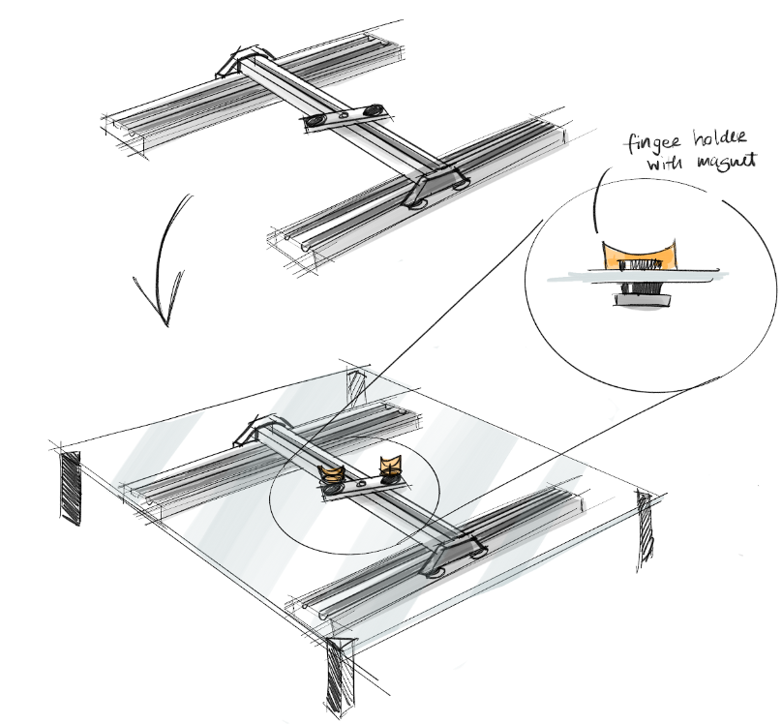

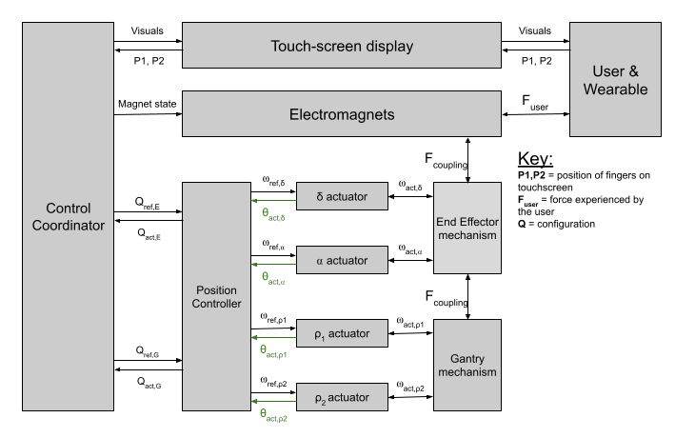

**Plan**

1. Remove the gantry from an old/cheap 3D printer
2. Add an end actuator and two magnets
3. Add an acrylic screen and two 3D printed pucks with magnets for the fingers

**Key Questions**

1. Is the gantry easy to move in both X and Y directions?
2. Is there a concerning amount of friction in either direction? Or inertia?
3. Can the gantry follow along with our magnets?

## 

## B. OPEN/CLOSED CHAIN

**Sketches + Block Diagram**

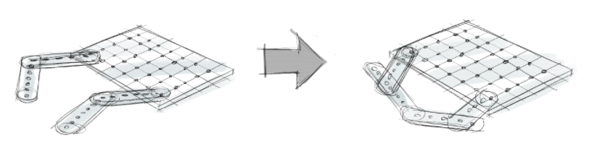

Double 2DOF Open Chain Linkage:

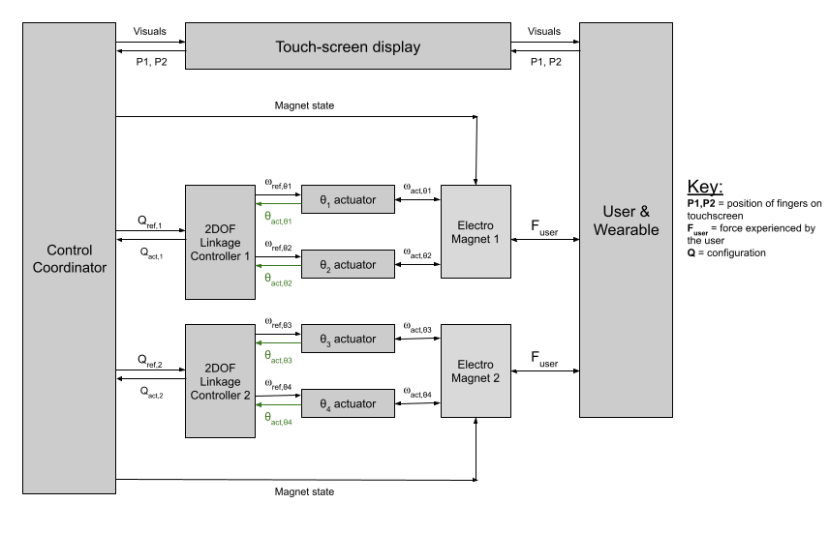

Closed chain linkage:

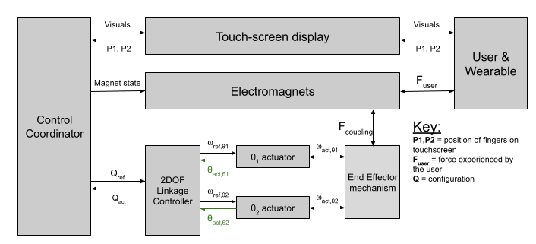

**Plan**

1. Laser cut acrylic matrix and chain links with multiple holes for size adjustments
2. Attach parts with nuts and bolts

**Key Questions**

1. Can we reach all points of the work surface?
2. Which lengths of links work best? Does having all links be the same length work best for reaching everywhere in the workspace?
3. Do all links need to be straight? i.e. does a right angle or curve in a link improve the manipulability ellipsoid in any way?
4. How can we maximize the condition number of the system everywhere in the workspace, i.e. make the system work best
5. Can we avoid singularities?
6. How does it feel? How can we relate this to our inertia of free motion requirement?

## 

## C. CABLE

**Sketches + Block Diagram**

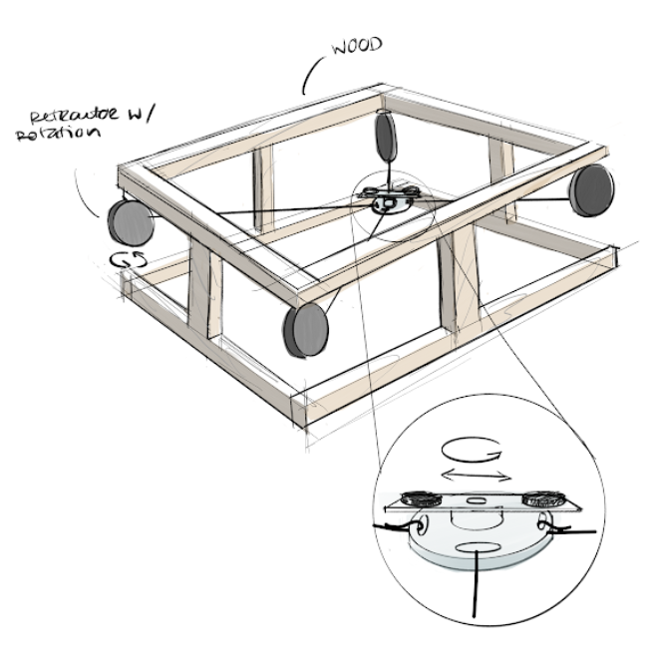

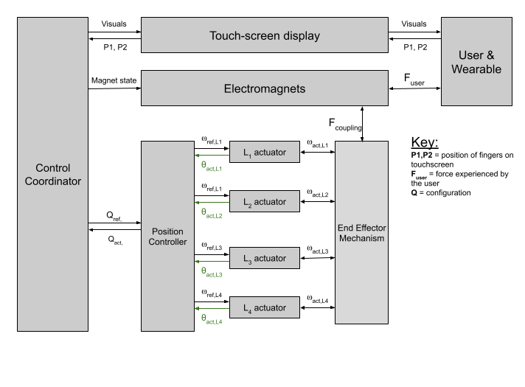

**Plan**

1. Get 4 retractors from McMaster
2. Attach them to a wooden/3D printed structure
3. 3D print an end effector w 2DOF
4. Attach end effector to retractors

**Key Questions**

1. Can we effectively maintain tension in each of the cables?
2. How much z-droop is there in the system? Does it change with XY position?
3. Is there a lot of friction in the system? Does it feel good?

## 

## 

## D. PSEUDO-TOUCH SCREEN

**Sketch**

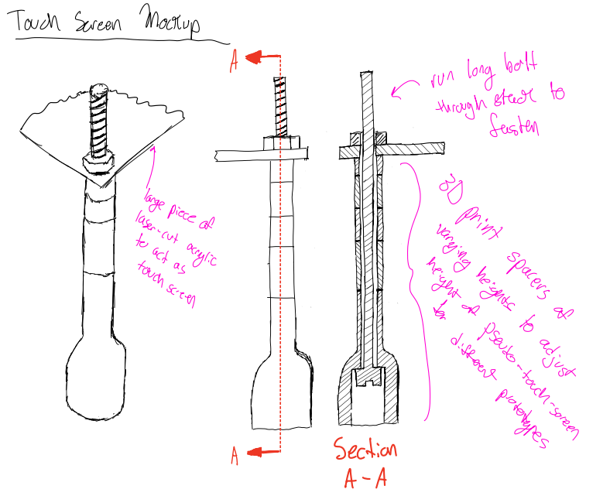

**Plan**

1. CAD different length spacers in SolidWorks with acrylic pseudo-touch-screen
2. Laser cut/3D print appropriate parts
3. Order long bolts from McMaster (shop only has up to 2”)
4. Order magnets from McMaster
5. Assemble

**Key Questions**

1. How do the magnets feel sliding across the surface on their own?
2. How can we design something around the magnets to improve their motion?
3. How do the other prototypes interact with a touch screen?
4. How might the mechanisms package underneath a screen?